What is Spark?
Apache Spark is an open-source, distributed data processing framework designed for big data. It enables fast, in-memory computing, making it ideal for processing large datasets and performing complex computations. Spark is known for its ease of use, extensive libraries, and versatility for tasks like batch processing, real-time data streaming, machine learning, and graph processing.

Spark Architecture
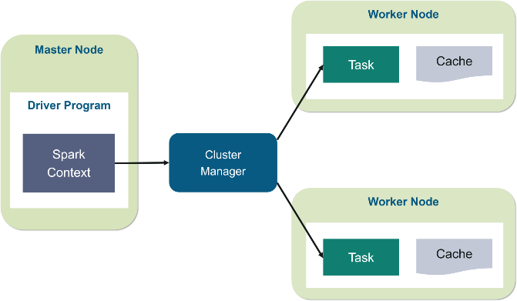
Spark's architecture is based on a master-slave model, involving the following key components:
- Driver Program:
  - The main entry point of a Spark application.
  - It defines the application's tasks and manages the overall job execution.
  - The driver program runs the main function, creates the SparkContext, and sends tasks to the executors.
- SparkContext: Created within the driver program, it serves as the gateway to Spark. SparkContext connects to a cluster manager to allocate resources across nodes.
- Cluster Manager:
  - Manages resources for the Spark application.
  - Spark supports various cluster managers, including:
    - Standalone: Default Spark cluster manager.
    - YARN: Commonly used with Hadoop clusters.
- Executors: Worker nodes that execute tasks and store data for processing. Executors receive tasks from the driver and run computations on data. They store data in memory to speed up computations (in-memory processing).
- Tasks: Smallest units of work sent to executors by the driver. Tasks perform specific computations on partitions of data.
- Jobs and Stages:
  - Job: A collection of tasks created by an action (e.g., count()).
  - Stage: if an operation like a shuffle (e.g., groupBy) requires data from multiple partitions to be combined, Spark will split the job into two stages: one stage for processing data before the shuffle, and another for handling tasks after it. These stages are executed in sequence, with each stage’s tasks processed across distributed executors.
SparkContext: SparkContext is the primary entry point for Spark applications, managing resources and communication with the cluster (e.g., YARN) and coordinating tasks. It allows low-level control over distributed data operations, mainly using RDDs (Resilient Distributed Datasets). SparkContext is essential for setting up Spark in older versions but is now generally replaced by SparkSession for simplicity.
SparkSession: SparkSession is the unified entry point in Spark 2.x and later, managing all Spark operations, including SQL, DataFrames, and machine learning. It encapsulates SparkContext and SQLContext internally, offering a single interface for structured data handling. SparkSession is now the preferred API for working with Spark due to its ease of use and versatility.
Note: API stands for Application Programming Interface. It is a set of rules that allows different software applications to communicate with each other.
Features of Apache Spark over MapReduce:
- Speed: Spark is much faster than MapReduce due to in-memory processing (reducing disk I/O).
- Ease of Use: Spark provides high-level APIs (e.g., PySpark, Scala) and a richer set of operators (e.g., map, filter, reduce, join).
- Fault Tolerance: Spark uses Resilient Distributed Datasets (RDDs) to handle faults, automatically recomputing lost data.
- Real-Time Processing: Spark supports stream processing through Spark Streaming, unlike MapReduce, which is batch-based.
- Unified Processing: Spark supports batch, streaming, machine learning (MLlib), and graph processing (GraphX) in one platform.
- Complex Operations: Spark handles complex data transformations more efficiently than MapReduce due to its advanced DAG (Directed Acyclic Graph) execution engine.
When MapReduce is Better:
- Large-Scale, Simple Batch Jobs: For simple, large-scale batch processing tasks where speed isn't critical, MapReduce can still be sufficient.
- Low Memory Requirements: If the dataset fits entirely into disk and memory usage is a concern, MapReduce can be more resource-efficient.
- Legacy Systems: If your existing ecosystem is built around MapReduce (e.g., Hadoop), it might be simpler and more cost-effective to stick with it.
Q.Why Spark is not good for small dataset?
For small datasets (10 MB to 1 GB), Spark might not offer a significant performance advantage over traditional tools like pandas or SQL databases due to its distributed processing overhead. While Spark excels with large datasets and complex operations, for small data, its setup and resource usage can be inefficient. For simple tasks, tools like pandas may be faster and more efficient. Spark is best leveraged for large-scale, distributed data processing tasks.
Spark Execution Plan
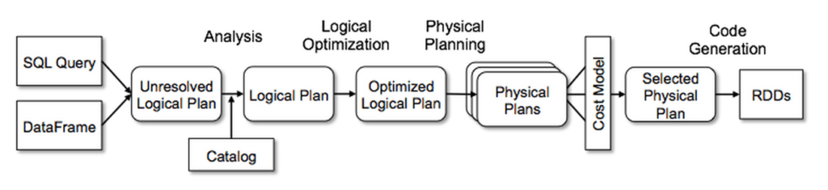
- Job Submission: You submit the job to the Driver. The Driver is responsible for managing and coordinating the entire job.
- Execution Plan Creation: Based on the actions, Jobs are created. Spark analyzes the job and creates an execution plan in the form of a DAG (Directed Acyclic Graph). The DAG represents all the operations (like map, filter, reduce) and the dependencies between them. It divides the job into stages based on wide transformations (e.g., groupBy, join) that require data shuffling.
- Stage and Task Division: The DAG is divided into stages, and each stage is split into smaller tasks. Each task will work on a partition of the data and can run in parallel across available workers (Executors).
- Task Scheduling: The Driver sends tasks to the Cluster Manager (e.g., YARN, Mesos, Standalone mode), which handles resource allocation. The Cluster Manager assigns tasks to Executors (worker nodes) based on available resources.
- Task Execution: Executors process the tasks, performing operations like map, filter, reduce on the data. This happens in-memory for faster processing. If the data is too large to fit into memory, Spark may spill it to disk.
- Shuffling (If Necessary): For wide transformations (like groupBy or join), data must be reshuffled across nodes. This is an expensive operation involving disk and network I/O. Spark handles the shuffle to ensure data is correctly distributed for further operations.
- Completion: Once all tasks are completed, the Executors send the results back to the Driver. The Driver collects the output, and the job finishes.
- Result and Logs: The output is either returned to the user (e.g., through collect()) or written to external storage (e.g., HDFS, S3). Logs are generated to help monitor performance and debug any issues.
Optimization Techniques:

1. Data Serialization (Parquet/ORC)
- Use columnar formats like Parquet or ORC instead of row-based formats (CSV, JSON) for better compression and faster read/write operations.
- Compression: Use Snappy compression for better speed and space efficiency.
df.write.format("parquet").option("compression", "snappy").save("path")

2. Caching and Persisting
- Cache DataFrames or RDDs that are used multiple times in the job to avoid recomputing them.
- Use df.cache() or df.persist() with the appropriate storage level (MEMORY_ONLY, MEMORY_AND_DISK).
df.cache() # Cache in memory
df.persist(StorageLevel.MEMORY_AND_DISK) # Cache in memory or disk

3. Avoid Shuffling
- Broadcast joins: For small DataFrames, use broadcast joins to avoid expensive shuffling.
from pyspark.sql.functions import broadcast
df1.join(broadcast(df2), on="key")
- Repartition before joining on non-partitioned columns to avoid shuffle overhead.

4. Dynamic Allocation
- Enable dynamic allocation to automatically scale the number of executors based on the workload.
spark.conf.set("spark.dynamicAllocation.enabled", "true")
spark.conf.set("spark.dynamicAllocation.minExecutors", "1")

5. Spark Configuration Tuning
- Executor Memory and Cores: Tune memory and CPU configurations for executors to match the resource needs of your job.
spark.conf.set("spark.executor.memory", "4g")
spark.conf.set("spark.executor.cores", "4")
spark.conf.set("spark.num.executors", "10")

6. Partitioning Strategy
- Repartitioning: Use repartition() for shuffling data when required, and coalesce() to reduce partitions after filtering.
df = df.repartition(100) # Increase partitions
df = df.coalesce(10) # Reduce partitions

7. Data Skew Handling
- Salting: Mitigate data skew during joins by adding random keys (salting) to distribute data more evenly.
from pyspark.sql.functions import monotonically_increasing_id
df = df.withColumn("salt", monotonically_increasing_id() % 10)

8. Executor Memory Overhead
- Set memory overhead to handle non-heap operations such as shuffling and caching.
spark.conf.set("spark.executor.memoryOverhead", "2g")

9. Spark UI and Monitoring
- Leverage Spark UI to monitor job stages, task distribution, and executor performance.
- Identify stages where performance bottlenecks occur and adjust configurations accordingly.

10. Cluster and Executor Tuning
- Ensure optimal resource allocation by tuning the number of executors, cores, and memory per executor based on job size and complexity.

Q. What would happen if my Spark job fails while processing ~10TB of data, and I'm using Hadoop vs. Databricks?
In Hadoop, checkpointing in Spark works by saving intermediate data to a persistent storage system like HDFS, allowing a job to resume from the last checkpoint rather than starting fresh. Spark uses metadata saved with the checkpoint, including job-specific lineage and transformation information, to recognize where the processing left off. This helps Spark resume from the last saved stage, even if nodes in the cluster are new or have been reallocated.
In Databricks (Delta Lake): If you're using Delta Lake, it automatically manages transaction logs and versioning, allowing the job to resume from the last successful commit point, making the retry faster and avoiding data reprocessing.
Q. How to decide the executor memory and number of executors?
It also depends on how much data we have and its partitions to shuffle. Number of cores must be the multiple of partition. For example:
6 machines, 16 cores(total = 96 cores), 64GB RAM each
Cores calculations: 96 – no. of machine for I/O operation(1 core from each) = 90
No of cores per machine = 90/6 => 15, here we can have 5 cores for 3 executors pe machine
No of executors: 3*6 = 18

Memory Calculation:
- 6 machines with 64GB RAM each.
- Total RAM per machine = 64GB.
- System overhead (30%): 19.2GB.
- Memory for executors: 70% of the available memory.
- System overhead (30%):
64GB×30%=19.2GB64GB \times 30\% = 19.2GB64GB×30%=19.2GB Round it to 20GB for simplicity.
- Remaining memory for executors (70%):
64GB−20GB=44GB64GB - 20GB = 44GB64GB−20GB=44GB
So, 44GB of memory per machine is available for executors.
Now, divide this 44GB across 3 executors, Round it to 14GB for simplicity.
- Heap memory (60% of total memory): 14GB×60 Round it to 8GB for simplicity.
- Memory overhead (40% of total memory): 14GB×40% Round it to 6GB for simplicity. (30-40% is safe)
Formula:
- Find the number of partitions first. 10gb file = 80 partitions of 128mb
- Find the number of cpu cores for maximum parallelism = 80 cores
- Find max allowed cpu cores per executors = 5 cores
- Number of executors = remaining cores/ executor cores: 80/5 = 16
- We need 4x(128mb per partition) memory for each cores = 128X4 = 512mb memory per partition
- Total memory per executor: 512X16 = 2560mb ~= 3gb

Q: What is lazy evaluation?
When you define transformations (like cache(), filter(), select(), etc.) in PySpark, no executors are started, and no actual work is done. These transformations are lazy, meaning they only describe the operations to be performed but don't trigger any computation.
- DAG Creation:
  - Spark builds a DAG (Directed Acyclic Graph) that represents the sequence of operations based on the transformations you've defined. This DAG is a logical plan that describes what operations need to be performed but doesn't initiate any data processing yet.
- No Executors Started:
  - Since transformations don't trigger execution, no executors or tasks are launched. The data isn't loaded, and the operations aren't executed on the workers.

